Saint John Lutheran Church

We trust God and invite you to experience God’s inclusive love!

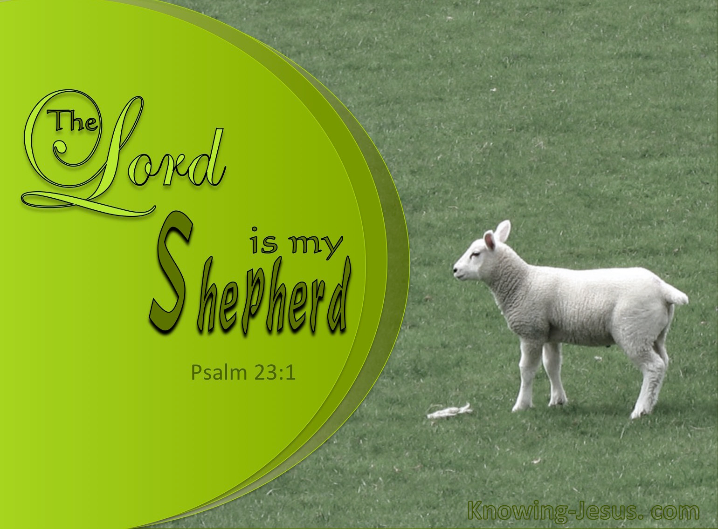

Fourth Sunday of Easter
April 21, 2024
10:00 AM

SCHEDULE FOR THE WEEK OF April 21
Sunday, April 21 Fourth Sunday of Easter
9:00 am Sunday School
10:00 am Worship
11:30 am Council
11:30 am Fellowship
5:30 pm AA Primary Purpose

Monday, April 22 Office Closed
7:00 pm AA Primary Purpose
7:00 pm Easy Does It Al-Anon

Tuesday, April 23 10:30 am Centering Prayer
12:30 pm Theology on Tap
6:30 pm Scouts
7:00 pm AA Primary Purpose

Wednesday, April 24 6:30 pm Worship

Thursday, April 25 10:00 am Mat Weaving
12:00 pm Al-Anon

Saturday, April 27 10am-1pm St. John Studio
2:30 pm AA Primary Purpose: Kitchen & FH

Sunday, April 28 Fourth Sunday of Easter
9:00 am Sunday School
10:00 am Worship
11:30 am Fellowship
5:30 pm AA Primary Purpose

Serving Saints today Serving Saints Next Week
Crucifer: Vaughn Maples Crucifer: Savannah Harvil
Reader: Gary Larson Reader: Jill Roy
Altar Guild: Don Taylor Altar Guild: Tish Martin
Assisting Minister: Larry Schultz Assisting Minister: Gwen Taylor
Ushers: Harry and Sharon Willard Ushers: Charlie and Tish Martin
Stewards: Vaughn Maples and Jill Roy Stewards: Vaughn Maples & Frank Dansby
Fellowship: Don Taylor Fellowship: Elaine Bell
Greeter: Sharon Willard Greeter: Connie Klopfenstein

GATHERING

Prelude

Welcome

Welcome! The Holy Spirit calls us together as the people of God.

The assembly stands in body or spirit.

Thanksgiving For Baptism
Blessed be the holy Trinity, ☩ one God, the wellspring of grace, our Easter and our joy. Amen.

Look, here is water!
Here is our water of life! Alleluia!

Immersed in the promises of baptism, let us give thanks for what God has done for us. We give you thanks, O God, for in the beginning your voice thundered over the deep and water became the essence of life. Adam and Eve beheld Eden’s verdant rivers. The ark carried your creation through the flood into a new day. Miriam led the dancing as your people passed through the sea into freedom’s land. In a desert pool the Ethiopian official entered your boundless baptismal life.

Look, here is water!
Here is our water of life! Alleluia!

At the river your beloved Son was baptized by John and anointed with the Holy Spirit. By the baptism of Jesus’ death and resurrection you opened the floodgates of your reconciling love, freeing us to live as Easter people. We rejoice with glad hearts, giving all honor and praise to you, through the risen Christ, our source of living water, in the unity of the Holy Spirit, now and forever. Amen.

Look, here is water!
Here is our water of life! Alleluia!

Our mission here at St. John is…
We trust God and invite you to experience God’s inclusive Love!

Gathering Song The Trumpets Sound, the Angels Sing ELW #531

Greeting
The grace of our Lord Jesus Christ, the love of God, and the Communion of the Holy Spirit be with you all. And also with you.

Hymn of Praise p. 169

The Prayer of the Day
Lord Christ, good shepherd of the sheep, you seek the lost and guide us into your fold. Feed us, and we shall be satisfied; heal us, and we shall be whole. Make us one with you, for you live and reign with the Father and the Holy Spirit, one God, now and forever. Amen.

The assembly is seated.
WORD

Acts 4:5-12
⁵The next day [the] rulers, elders, and scribes assembled in Jerusalem, ⁶with Annas the high priest, Caiaphas, John, and Alexander, and all who were of the high-priestly family. ⁷When they had made the prisoners stand in their midst, they inquired, “By what power or by what name did you do this?” ⁸Then Peter, filled with the Holy Spirit, said to them, “Rulers of the people and elders, ⁹if we are questioned today because of a good deed done to someone who was sick and are asked how this man has been healed, ¹⁰let it be known to all of you, and to all the people of Israel, that this man is standing before you in good health by the name of Jesus Christ of Nazareth, whom you crucified, whom God raised from the dead. ¹¹This Jesus is
‘the stone that was rejected by you, the builders;
it has become the cornerstone.’
¹²There is salvation in no one else, for there is no other name under heaven given among mortals by which we must be saved.”

Word of God, word of life. Thanks be to God.

Special Music Gary Larson

1 John 3:16-24
¹⁶We know love by this, that [Jesus Christ] laid down his life for us—and we ought to lay down our lives for one another. ¹⁷How does God’s love abide in anyone who has the world’s goods and sees a brother or sister in need and yet refuses help?
¹⁸Little children, let us love, not in word or speech, but in truth and action. ¹⁹And by this we will know that we are from the truth and will reassure our hearts before him ²⁰whenever our hearts condemn us; for God is greater than our hearts, and he knows everything. ²¹Beloved, if our hearts do not condemn us, we have boldness before God; ²²and we receive from him whatever we ask, because we obey his commandments and do what pleases him.
²³And this is his commandment, that we should believe in the name of his Son Jesus Christ and love one another, just as he has commanded us. ²⁴All who obey his commandments abide in him, and he abides in them. And by this we know that he abides in us, by the Spirit that he has given us.

Word of God, word of life. Thanks be to God.

The assembly stands in body or spirit.

Gospel Acclamation 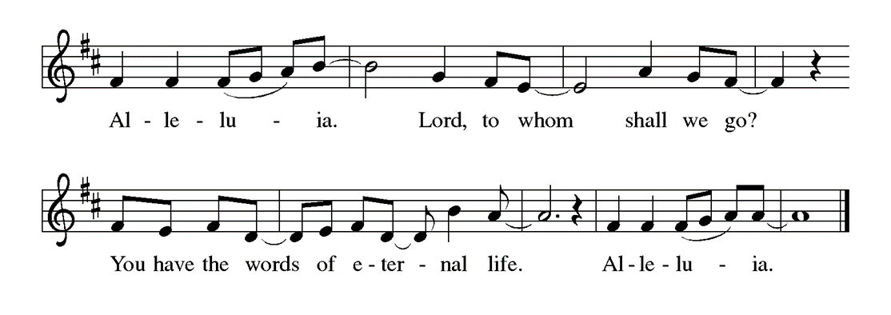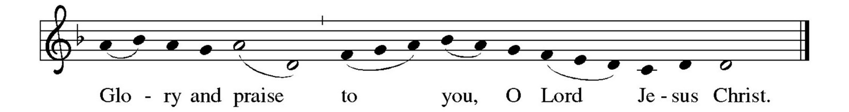

The Holy Gospel according to John. Glory to you, O Lord.

John 10:11-18
[Jesus said:] ¹¹“I am the good shepherd. The good shepherd lays down his life for the sheep. ¹²The hired hand, who is not the shepherd and does not own the sheep, sees the wolf coming and leaves the sheep and runs away—and the wolf snatches them and scatters them. ¹³The hired hand runs away because a hired hand does not care for the sheep. ¹⁴I am the good shepherd. I know my own and my own know me, ¹⁵just as the Father knows me and I know the Father. And I lay down my life for the sheep. ¹⁶I have other sheep that do not belong to this fold. I must bring them also, and they will listen to my voice. So there will be one flock, one shepherd. ¹⁷For this reason the Father loves me, because I lay down my life in order to take it up again. ¹⁸No one takes it from me, but I lay it down of my own accord. I have power to lay it down, and I have power to take it up again. I have received this command from my Father.”

The Gospel of the Lord. Praise to you, O Christ.

The assembly is seated.

Sermon Vicar Roxann Thompson

Silence is kept for reflection.

The assembly stands in body or spirit.

Hymn of the Day You, Lord, are Both Lamb and Shepherd Bulletin P.17

Apostles’ Creed
I believe in God, the Father almighty,
creator of heaven and earth.

I believe in Jesus Christ, God’s only Son, our Lord,
who was conceived by the Holy Spirit,
born of the virgin Mary,
suffered under Pontius Pilate,
was crucified, died, and was buried;
he descended to the dead.
On the third day he rose again;
he ascended into heaven,
he is seated at the right hand of the Father,
and he will come to judge the living and the dead.

I believe in the Holy Spirit,
the holy catholic Church,
the communion of saints,
the forgiveness of sins,
the resurrection of the body,
and the life everlasting. Amen

Prayers of Intercession
Rejoicing that Jesus is risen, and love has triumphed over fear, let us pray for the church, the world, and all those in need of good news.

A brief silence.

Shepherding God, gather your church whenever we wander from you and one another. Empower our church in ministries around the world to worship and serve alongside global companions as equal partners and coworkers in the gospel. Bless the ministry of Agustinian Lutheran School, Guatemala and St. Johannes, Bavaria. We pray for Grace Missions and Chez Moi Orphanage, Haiti, that together we press on toward the goal of your heavenly call in Jesus Christ. God of grace, hear our prayer.

Nurturing God, preserve the health of biomes and ecosystems. Inspire scientists, researchers, conservation organizations, and all people entrusted with the task of caring for creation, that we may be better stewards of the world around us.
God of grace, hear our prayer.

Loving God, protect the very young and the very old, those living without housing, victims of domestic abuse, and all who live with chronic illness or compromised immune systems, especially, Cathleen Dahl, William Panick, Susan and David Friend, Maureen Caldwell, Andy and June Harnack, John Bennett, Sarah Lanier, Catherine Campbell, Bobbi and Les Windsor, Sandra Harwood, Debbie Sakmar, Beau and Janet Kindred, Cheryl Maples, Lanny Cox, Leanne Powell, April Kennedy, Betty Panick, Claudia Nicholas, Mary Johnson, Bill Gates, Enid Mswia, Lorelei Kompelien and family. God of grace, hear our prayer.

God of celebrations, you celebrate with those who are celebrating birthdays, Susan Friend; those celebrating baptismal birthdays, Savannah Harvil; attending seminary, Ethan Miller. God of grace, hear our prayer.

Gracious God, help this and all communities of faith to listen for your voice. Call us away from things that distract us from following you. Invite us to more deeply love and serve people who are lonely, isolated, and on the margins.
God of grace, hear our prayer.

We lift up all others we name in our hearts or on our lips….. (Pause).
God of grace, hear our prayer.

Living God, we give thanks for our ancestors in faith. Strengthen us to share the good news in our own day. God of grace, hear our prayer.

Into your hands, most merciful God, we commend all for whom we pray, trusting in your abiding love; through Jesus Christ, our resurrected and living Lord. Amen.

MEAL

We receive and extend to one another the gift of Christ’s peace. A collection of material goods for the church’s mission is gathered as a sign of the giving of our whole selves in grateful response for all of God’s gifts. The table is set with bread and wine. A gift of music is offered, and prayers of thanksgiving are sung and spoken.

We Share the Peace of the Lord
The peace of Christ be with you always. And also with you.

The assembly is seated as the music begins to play.

Choir

Organ Offertory (Gathering of Gifts)
At this time, the ushers will pass the offering plates.

The assembly stands in body or spirit as we sing the offering hymn and present the gifts.
Offering Hymn Come to the Table #481

Offering Prayer
Risen One, you call us to believe and bear fruit. May the gifts that we offer here,
be signs of your abiding love. Form us to be your witnesses in the world, through Jesus Christ, our true vine. Amen.

Before the Lord’s Supper is shared, the presiding minister leads us in a prayer of thanksgiving (Eucharist) to God for creation and salvation, remembrance of the crucified and risen Christ, and the Holy Spirit’s presence
in this meal. The thanksgiving concludes with the prayer our Lord Jesus taught us.

The Great Thanksgiving
The Lord be with you.
And also with you.
Lift up your hearts.
We lift them to the Lord.
Let us give thanks to the Lord our God.
It is right to give our thanks and praise.

Preface for Easter
It is indeed right, our duty and our joy, that we should at all times and in all places give thanks and praise to you, almighty and merciful God, for the glorious resurrection of our Savior Jesus Christ, the true Paschal Lamb who gave himself to take away our sin; who in dying has destroyed death, and in rising has brought us to eternal life. And so, with Mary Magdalene and Peter and all the witnesses of the resurrection, with earth and sea and all their creatures, and with angels and archangels, cherubim and seraphim, we praise your name and join their unending hymn:

Holy, Holy, Holy
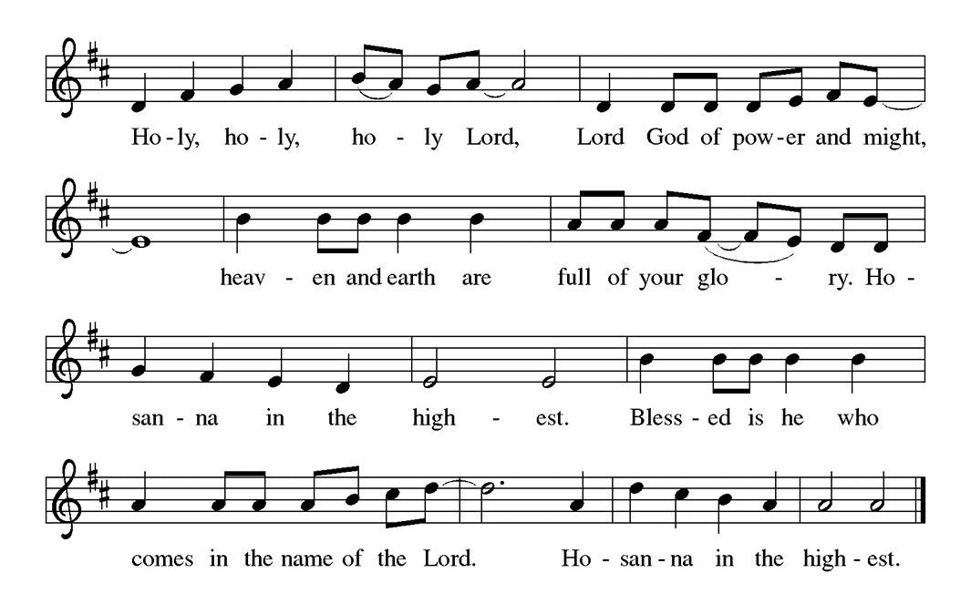

Eucharistic Prayer for Easter
Holy, living, and loving God,
we praise you for creating the heavens and the earth.
We bless you for bringing Noah and his family through the waters of the flood,
for freeing your people Israel from the bonds of slavery,
and for sending your Son to be our Redeemer.

We give you thanks for Jesus
who, living among us, healed the sick, fed the hungry,
and with a love stronger than death, gave his life for others.

In the night in which he was betrayed,
our Lord Jesus took bread, and gave thanks;
broke it, and gave it to his disciples, saying:
Take and eat; this is my body, given for you.
Do this for the remembrance of me.

Again, after supper, he took the cup, gave thanks,
and gave it for all to drink, saying:
This cup is the new covenant in my blood,
shed for you and for all people for the forgiveness of sin.
Do this for the remembrance of me.

Remembering, therefore,
his life-giving death and glorious resurrection,
we await your promised life for all this dying world.

Breathe your Spirit on us and on this bread and cup:
carry us in your arms from death to life,
that we may live as your chosen ones,
clothed in the righteousness of Christ.

Through him all glory and honor is yours,
Almighty Father, with the Holy Spirit,
in your holy Church, both now and forever.
Amen
Lord, remember us in your kingdom and teach us to pray:

Our Father, who art in heaven,
hallowed be thy name,
thy kingdom come, thy will be done,
on earth as it is in heaven.
Give us this day our daily bread;
and forgive us our trespasses,
as we forgive those who trespass against us;
and lead us not into temptation, but deliver us from evil.
For thine is the kingdom,
and the power, and the glory,
forever and ever. Amen

Invitation to Communion
The risen Christ is made known to us in the breaking of the bread.
Come and eat at God’s table.

The assembly is seated.

Lamb of God
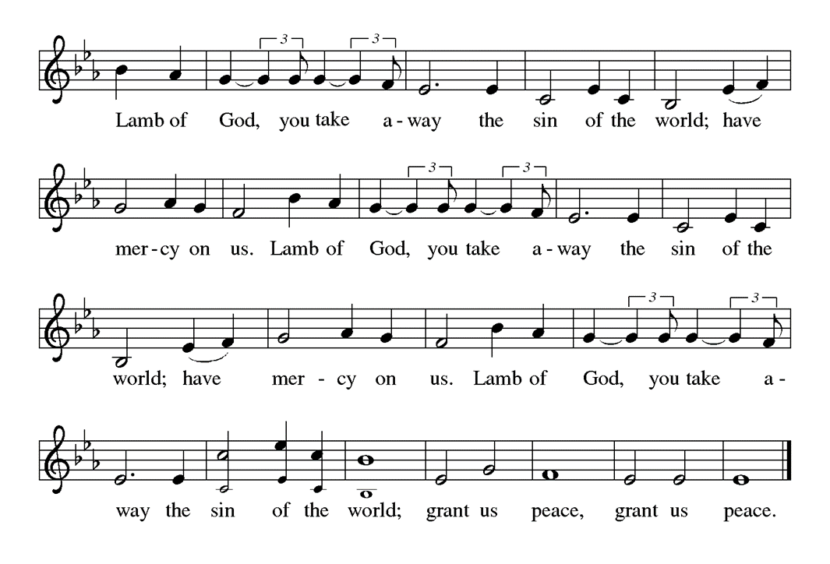

The congregation is encouraged to sing during the distribution:
You Satisfy the Hungry Heart ELW #484

The assembly stands in body or spirit.

Prayer after Communion
Shepherding God, you have prepared a table before us and nourished us with your love. Send us forth from this banquet to proclaim your goodness and share the abundant mercy of Jesus, our redeemer and friend. Amen.

SENDING

God blesses us and sends us in mission to the world.

Benediction
The God of resurrection power, the Christ of unending joy, and the Spirit of Easter hope ☩ bless you now and always. Amen.

During the sending hymn, please remain facing the cross.

Sending Hymn Praise the Lord, Rise Up Rejoicing ELW #544

Dismissal
As we go on our way, let us remember…
Through Jesus Christ, we are an equipping and responding church that continues to grow, impact, and transform lives.

Alleluia! Go in peace. Rejoice and be glad.
Thanks be to God. Alleluia!

Postlude

All liturgies, prayers, Bible passages and music are reprinted with permission from the following resources.
Augsburg Fortress Liturgies Annual License 23384; OneLicense.net. License #A-701923; CCLI License # 2725291 & 20964660.

ELW
531
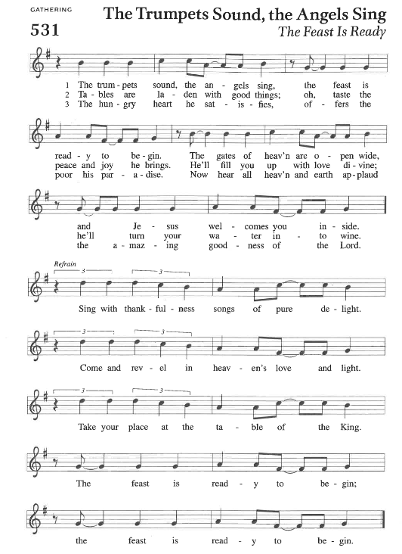
ELW
488
ELW
p. 169

(Continued on next page)
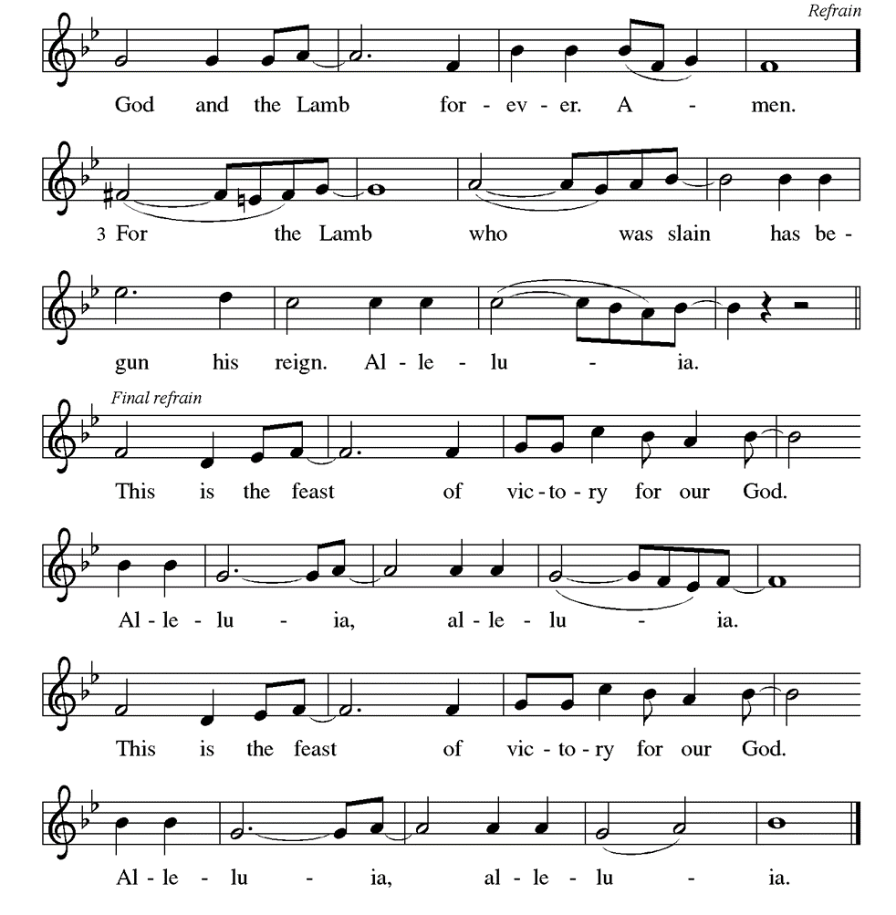
ACS
954
p.18
ACS
1072
ELW
481

ELW
484
ELW
488
ELW
544

IN OUR PRAYERS THIS WEEK – APRIL 21, 2024
ELW
36
Cathleen Dahl, William Panick, Susan and David Friend, Maureen Caldwell, Andy and June Harnack, John Bennett, Sarah Lanier, Catherine Campbell, Bobbi and Les Windsor, Debbie Sakmar, Beau and Janet Kindred, Cheryl Maples, Lanny Cox, Leanne Powell, April Kennedy, Betty Panick, Claudia Nicholas, Mary Johnson, Bill Gates, Enid Mswia, Lorelei Kompelien and Family.

Family and Friends: Leonard Rhyne, Liz and Bob Sherliza (friends of Saint John); Margaret Thompson (friend of Elaine Bell and Donna Milam); Charles Spurgeon (brother of Vickie Cash); Dawn Jacobs, Ray Long (friends and family of Terry Emlet and Mary Johnson); Cathy Westmoreland (friend of Gates); Patricia Freeman (grandmother of Savannah Harvil and Bailey Harvil-Sevier), Tim Kennedy (son of April Kennedy); Patsy Slagle (friend of Janet Kindred, Marilyn Droegmiller), Susan St. John, Scott Lanier (family and friends of Sarah Lanier); Barbara Shockley, Rick Thacker, Brenda Evans, Janet Kannady, Ramona Landreth (friends and sister of Cheryl Maples); Sue Tomsovic (Aunt of Tish Martin); Nilsa Scott (friend of Laura Miller); John Burger (son in law of Bonnie Nichols), Nancy Whilden, Patricia Wilson, Melissa Roy, (friend and family of Jill Roy); Michael Robinson and family, Doug Maxwell, Mallory DeLise and family (family of Debbie Sakmar); Lisa Maples (Daughter in Law of Debbie Sakmar and Vaughn and Cheryl Maples); Whitney O’Connor Hawk (granddaughter of Larry Schultz); Lisa Cesnik Ferguson (friend of Larry Stoermer); Julie Pate, Ricky Bradford (family of Peggy Thomas), Jeanie Tidwell (mother of Bill Tidwell); Jennifer and Bobby Mooneyham (parents of Tina Venus).

BIRTHDAYS Baptisms
4/26 Susan Friend 4/25 Savannah Harvil

Saint John Studio
The next class will be on April 27, 10am to 1 pm. In preparation of the spring holidays, we will be making cards. Everyone is welcome to join us, no matter your creative abilities! There will be light refreshments, good community, and great fun! We hope to see you there!

BIBLE STUDY, SUNDAY, APRIL 7 AT 3:30 PM VIA ZOOM
Please find the links for our Bible study guides for The Screwtape Letters by C.S. Lewis.

Primary Bible Study Guide
https://www.cslewisinstitute.org/wp-content/uploads/Screwtape_StudyGuideWeb_cor.pdf

Second Free Bible Study Guide
https://www.ashtoncatholic.org/screwtape

YOUTH GATHERING FUNDRAISER, MAY 5, 11:30AM
Come support our youth’s National Youth Gathering fundraiser! We will be having Gayle Harvil’s “famous” spaghetti immediately following worship. The kids are excited to share their artistic skills in a silent auction. You can bid on your favorite pieces for two Sundays! We hope to see you there!

Centering Prayer and theology on tap, tuesdays
Centering prayer will meet in the Adult Sunday School room at 10:30 am.

Theology on Tap will meet at Margo’s on Taylor Street at 12:30 pm. We are reading Jesus’ Alternative Plan: the Sermon on the Mount by Richard Rohr.

Mat Weaving: Thursdays at 10:00 am
We meet every Thursday at 10:00 am in the room across from the office. We need grocery bags, especially colorful bags. We encourage everyone to prayerfully consider joining us in this important ministry.

DAILY READINGS
Monday: Psalm 95, 1 Samuel 16:1-13, 1 Peter 5:1-5
Tuesday: Psalm 95, 1 Chronicles 11:1-9, Revelation 7:13-17
Wednesday: Psalm 95, Micah 7:8-20, Mark 14:26-31
Thursday: Psalm 22:25-31, Amos 8:1-7, Acts 8:1b-8
Friday: Psalm 22:25-31, Amos 8:11-13, Acts 8:9-25
Saturday: Psalm 22:25-31, Amos 9:7-15, Mark 4:30-32
Fifth Sunday of Easter: Acts 8:26-40, Psalm 22:25-31, 1 John 4:7-21, John 15:1-8

Saint John Lutheran Church
1689 Martin Luther King Jr. Parkway, Griffin, GA 30224
Church Phone: 770-228-0662
Email: stjohnelca@bellsouth.net
Website: www.stjohngriffin.org
Facebook: Saint John Evangelical Lutheran Church

Pastor Larry Boudon Roxann Thompson, Vicar
Pastor_st.john@yahoo.com Vicar.stjohn@yahoo.com
larryboudon@gmail.com 678-485-0430
786-383-8087 Office Hours:
Office Hours: Wednesday: 1pm-8pm
Tuesday & Wednesday, 9am-4pm

Church Office Hours: Tuesday-Friday, 10am-3pm

Support Staff
Lynn Jones, Administrative Assistant Larry Stoermer, Worship Broadcast Technician
Marilyn Droegmiller, Organist Savannah Harvil, Victoria Schuette. Youth Directors

Congregation Council
Phyllis Hutchings, President Connie Klopfenstein
Enid Mswia, Vice-President Donna Milam
Vaughn Maples, Secretary Gwen Parks
Tish Martin, Treasurer Gwen Flowers-Taylor
Steve Harwood, Financial Secretary

Ministry Contacts
Altar Guild Sandra Harwood 770-229-2071
Education
Fellowship Laura Miller, co-chair 770-468-5722
Martha Dansby, co-chair 770-719-8409
Finance Committee Tish Martin 678-378-0551
Steve Harwood 770-229-1204
Gifts and Memorials Tish Martin, chair 678-378-0551
Glocal Mission Larry Schultz, chair 404-304-9127
Member Care Sarah Lanier, chair 814-558-3152
Property Ministry Tish Martin, Chair 678-378-0551
Social Ministry
Stewardship
Children and Youth Ministry Savannah Harvil 678-603-6287
Victoria Schuette 762-832-0289
Worship Sandra Harwood, chair 404-993-7955

